Github screenshot

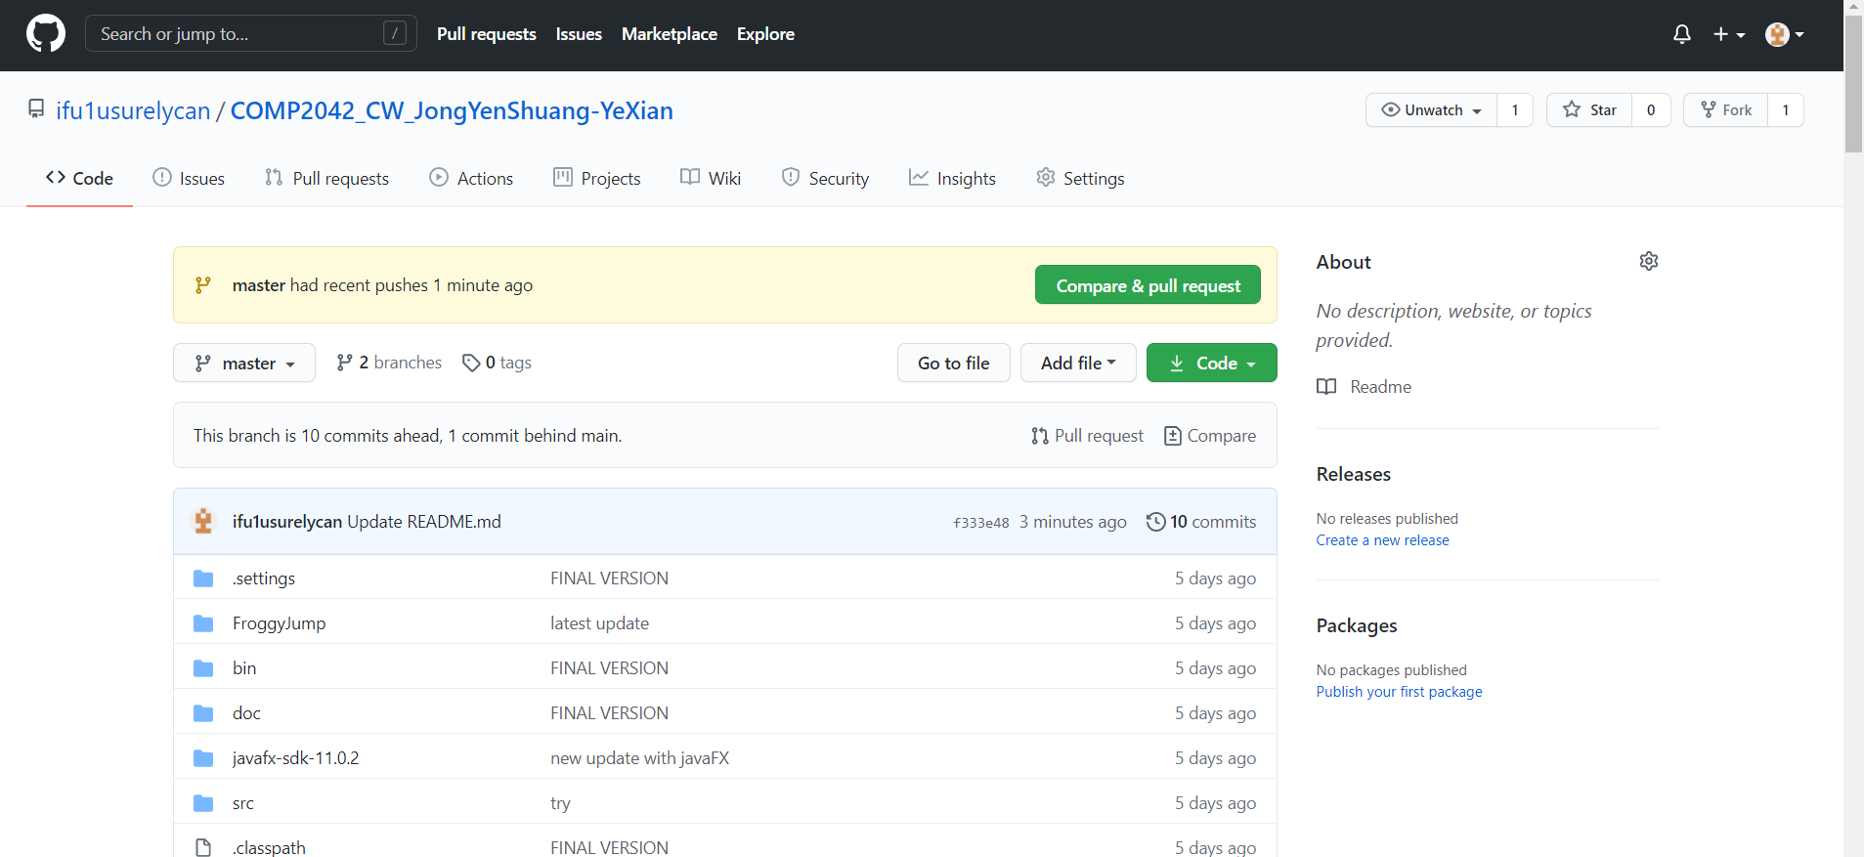

Prove of previous commit

